Year 8 PE homework project
‘Who is your sporting hero and why?’

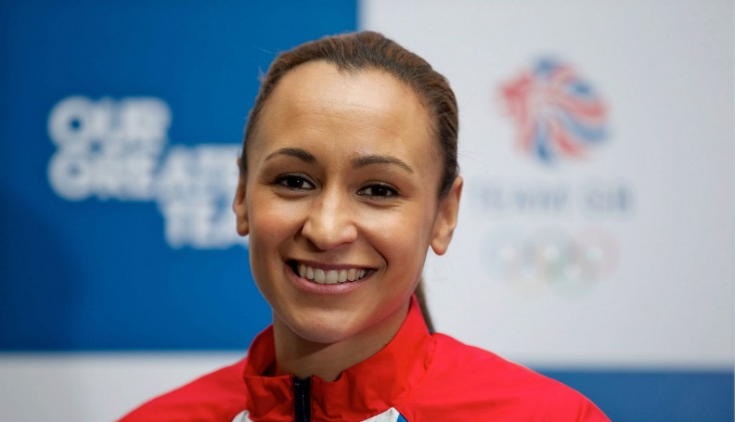
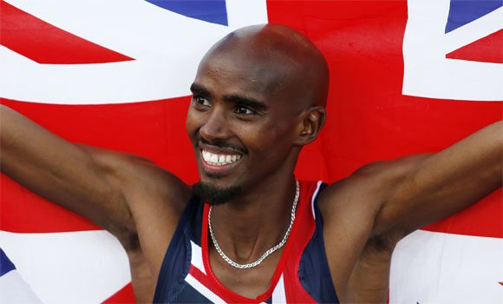

Hand out date:
Hand in date:
Task:
Research your sporting hero and explain why you feel inspired by them.

What do I need to include in my project?
- Write an introduction explaining who your project is about and what have you have been asked to do.
- Write a biography of the sporting life of your athlete. You might want to do this as a timeline from when they first got into their sport and where they are now.
- Pick one of their most successful sporting events in their career, write about this and explain how it was achieved. Do/did they have the support of a coach, family members? How do you think achieving this made them feel?
- Explain the reasons why you picked this person, how have they inspired you? Do you now compete in this sport because of them? Why do you consider them a role-model?

How should I present my work?
You can present this work in many different ways, a poster, a booklet, powerpoint presentation (all work must be printed off – USB sticks will not be accepted by your teacher), videos etc…

The best homework presentations will include many photos so be as creative as you can!

If your homework project is bright and eye catching we will use them for display!

